2023 SmileTree Sponsorship Report
January 12, 2024
Dear Friends –
As we enter 2024, Global Dental Relief celebrates an amazing 17 years of partnership with SmileTree/Climb for a Cause, dedicated to bringing dental care to children in need around the world!
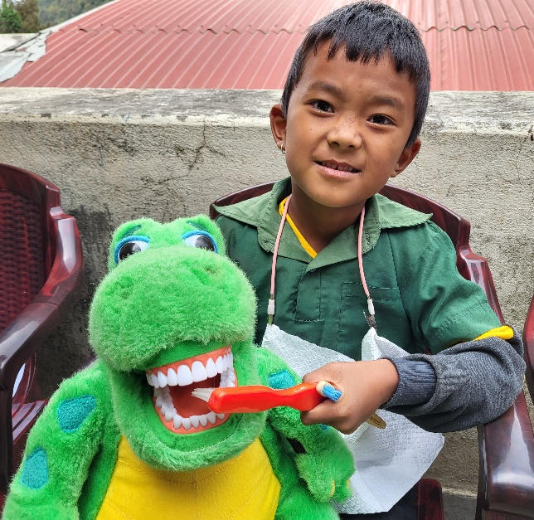
Working together, this partnership has allowed Global Dental volunteers to expand to new country locations, supported critical food and oral health programs, and provided supplies for week-long dental clinics in each of our global clinic locations. We are deeply grateful for this partnership and its lasting, important impacts.
In 2023, SmileTree/Climb for a Cause sponsored clinics in five countries, providing dental care and oral health education for 3595 children. Specifically, SmileTree/Climb for a Cause provided $5000 per clinic to purchase dental supplies. Funds provided critical restoration materials such as anesthetic, composite, and amalgam, as well as gloves, gauze and infection control materials. In addition, your sponsorship ensured each child received a new toothbrush and fluoride application as part of their clinic visit
Dental care was provided to school children who visited the clinic class by class. During their visit, each child received an exam, restorations and extractions as needed, oral health education at three locations in the clinic, a new toothbrush and a fluoride treatment. And most importantly, GDR is committed to see and treat these same children every 1.5 to 2 years for full checkups and dental care as long as they attend school.

2023, SmileTree/Climb sponsored clinics and the dental care provided are shown in the chart below:

Country | Date | Children Treated | Cleanings | Restorations | Value of Doanted Dental Care
Mexico | 27-May-23 | 538 | 190 | 184 | $112,870
Cambodia | 18-Jun-23 | 823 | 181 | 815 | $284,445
Guatemala | 21-Jul-23 | 814 | 359 | 475 | $211,420
India | 21-Aug-23 | 525 | 187 | 265 | $144,085
Nepal | 18-Nov-23 | 895 | 130 | 405 | $230,085
TOTAL |  | 3595 | 1047 | 2144 | $982,905

In 2023 Smiletree/Climb for a Cause clinics delivered care in 5 week-long dental clinics, serving 3595 children. Children received over 1000 cleanings, 2144 restorations and received in total, $982,905 in donated dental care.

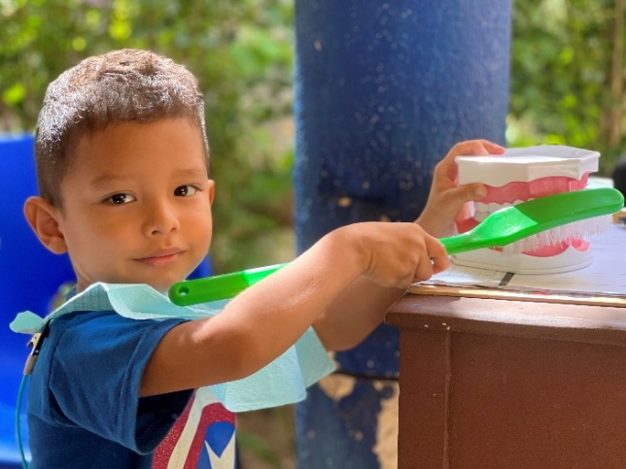
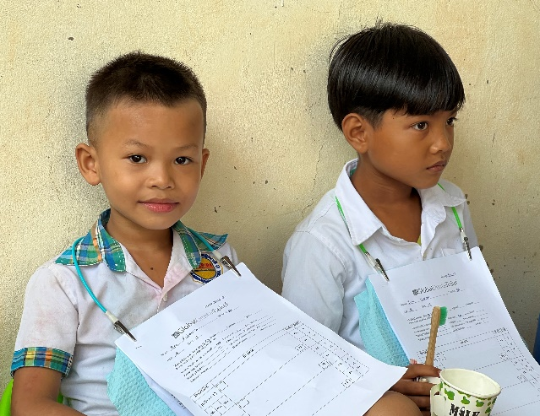

As you know, without treatment, children suffer from chronic pain and infection due to small, untreated cavities that grow over time and encompass an entire tooth. By bringing these populations to clinic, children receive the first dental care of their lives and also, the promise of ongoing care every 1 to 2 years for each student and their classmates.

This is the model – to return each child to oral health, and to teach them the basics of toothbrushing and nutrition. The hope of this work is to spread the knowledge of oral health and toothbrushing habits to each student, their families and, eventually. to the community at large.
Your generosity continues to make an immense difference in the lives of children. We at GDR are so thankful for your big hearts and long-standing partnership. Danny and Virginia, we are so deeply grateful!
From all of us and on behalf of the families we serve – Thank you, Namaste, Jullay, and Gracias!
Kim, Laurie and the GDR Team
